Computer Assignment 2 on Excel VBA (Fall 2020)

* Create a workbook and name it as Computer Assignment 2 - <your name>  
  Save the workbook as macroenabled.
* You should only have the following four problems saved in the Computer Assignment 2 - <your name> workbook and nothing else.

1. ABC company gives discount as follows:  
   Purchase > $400 Discount rate = 5%  
   Purchase between $300 and $400 Discount rate = 4%  
   Purchase >= $100 and < $300 Discount rate = 2%  
   Purchase < 100 No discount  
   Purchase = Price \* Quantity  
   Discount = Purchase \* Discount rate   
   Net Purchase = Purchase – Discount

Total Net Purchase is the running total of Net Purchases   
  
Create a user interface form as shown below. Use text boxes to input price and quantity. Use labels to display the discount, net purchase (purchase amount after discount) and total net purchases. Click calculate button to calculate and display discount, net purchase, and total net purchases; click clear button to clear values from the text boxes and labels, except total net purchases; send the focus to the price text box.   
Click exit button to end the application.  
(40 points – 20 points for designing the user interface and 20 points for the code)

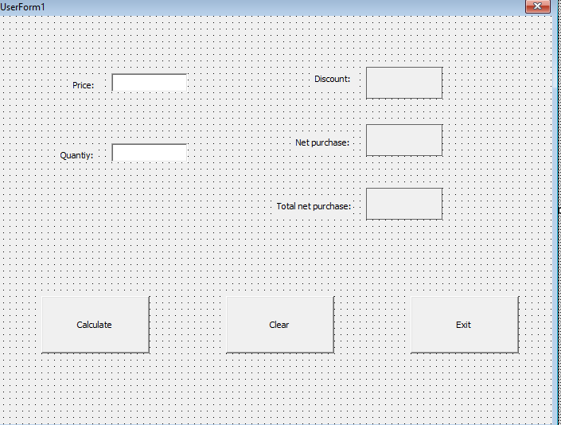

1. Create a sub procedure in a module to calculate:   
   a) the sum of even integers from 4 to 12 using DO WHILE. Display the sum in the message box. Name the sub procedure as Q2a.  
   b) the sum of odd integers from 5 to 9 using FOR NEXT. Display the sum in message box. Name the sub procedure as Q2b.   
   (30 points)
2. Create a sub procedure named as Question3 in a module to calculate the value and total value of items using a Do/while Loop. Value = Price \* Quantity. Total value is the running total of values. Use INPUTBOX function to get the price and quantity. Display the value in the message box. Display total value in the message box after exiting the loop. Loop is entered by inputting “Y” at the prompt “Do you wish to continue?” and exited by entering “N” at the prompt “Do you wish to continue?”   
   (15 points)
3. Create a sub procedure named as Question4 in a module to find the capital. Use INPUTBOX function to get the state and message box function to display the capital.

State Capital

MN St.Paul

WI Madison

TX Austin

(15 points)